Semi-Regular Tessellation
# Source: AI Source: Provided by: [Data Path: Persons Table -> ID Column: 1, Name_En Column: Motasem Essam] -> From: [ChatGPT] on [7/25/2026]
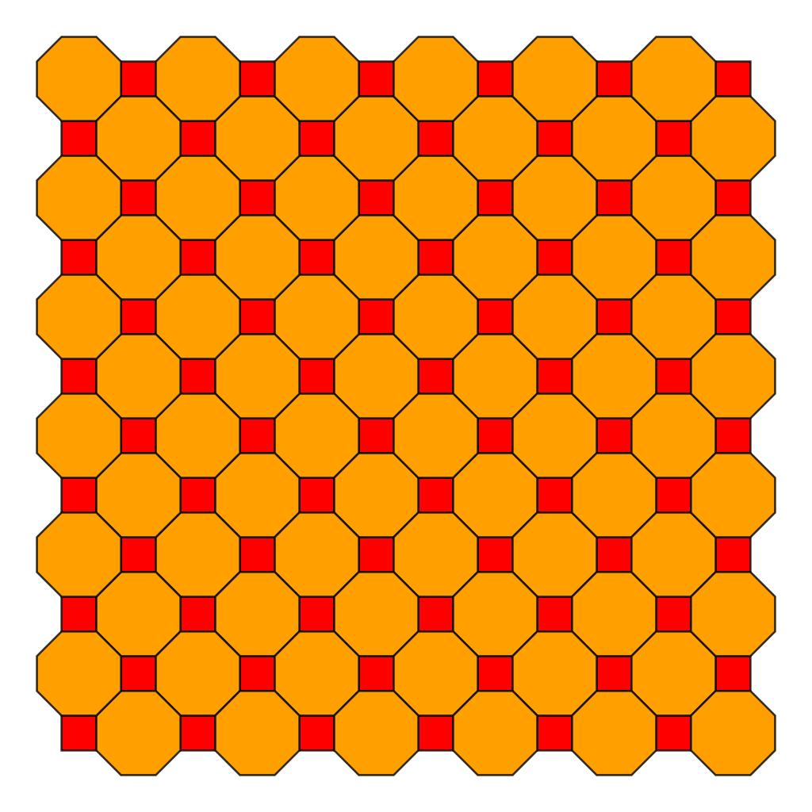
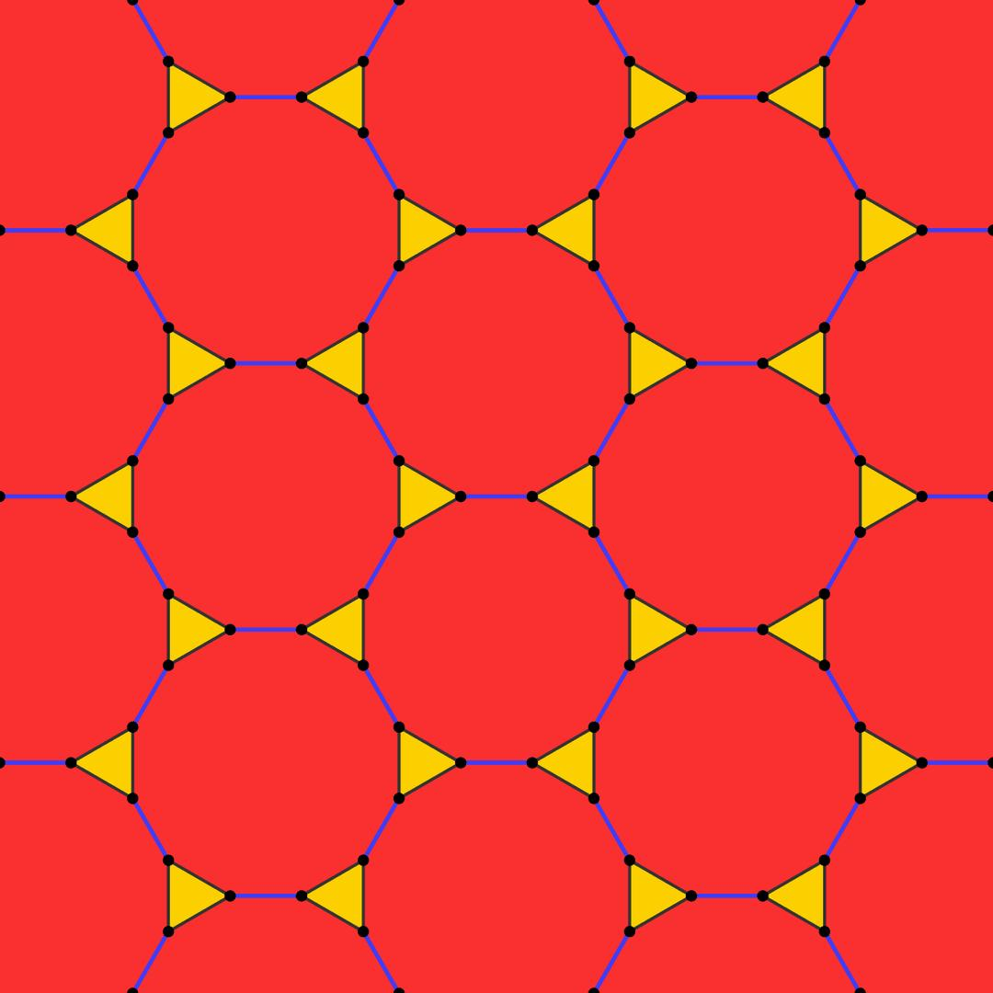
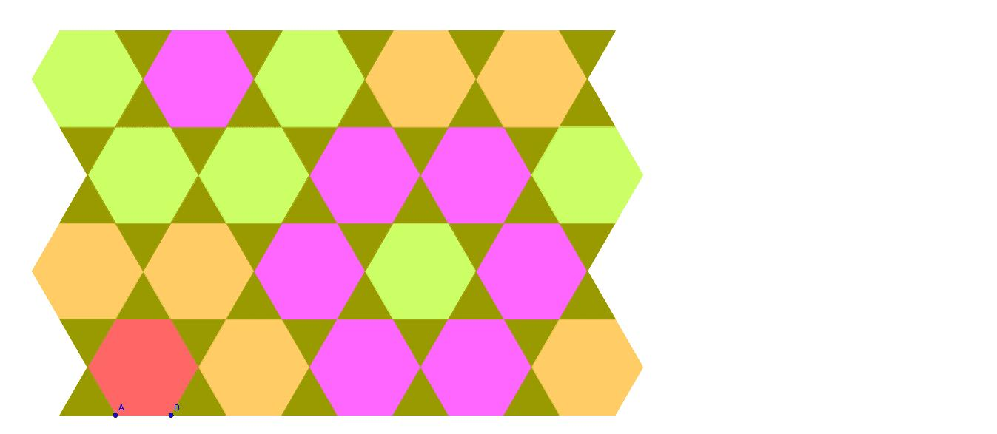
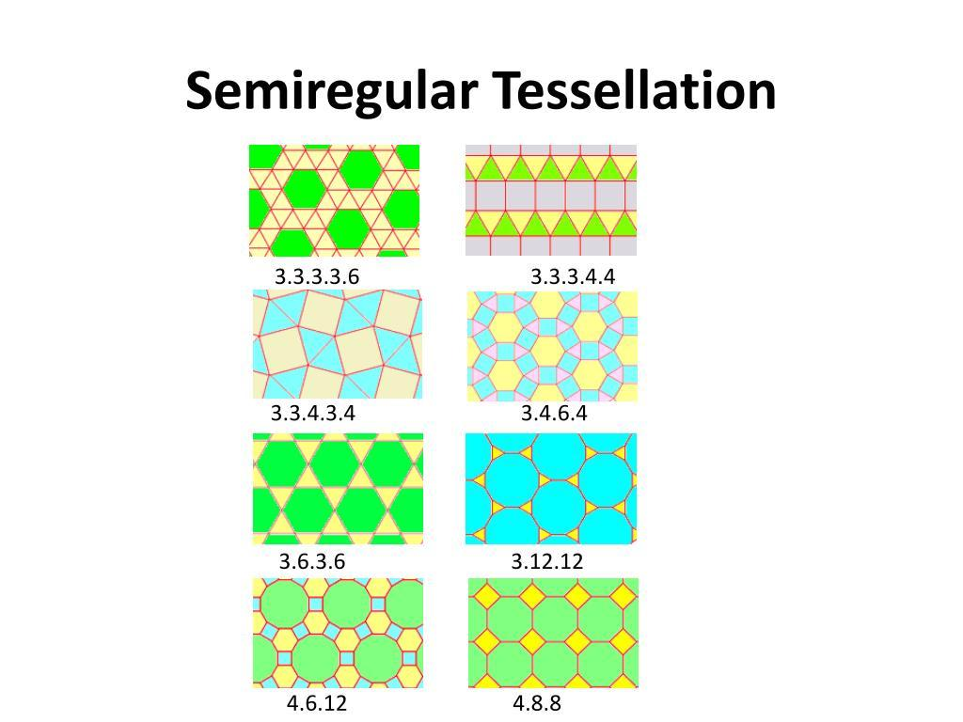
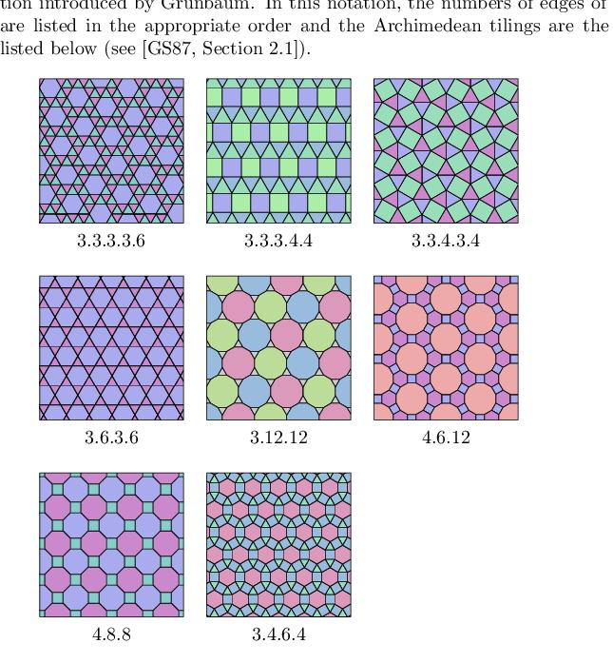
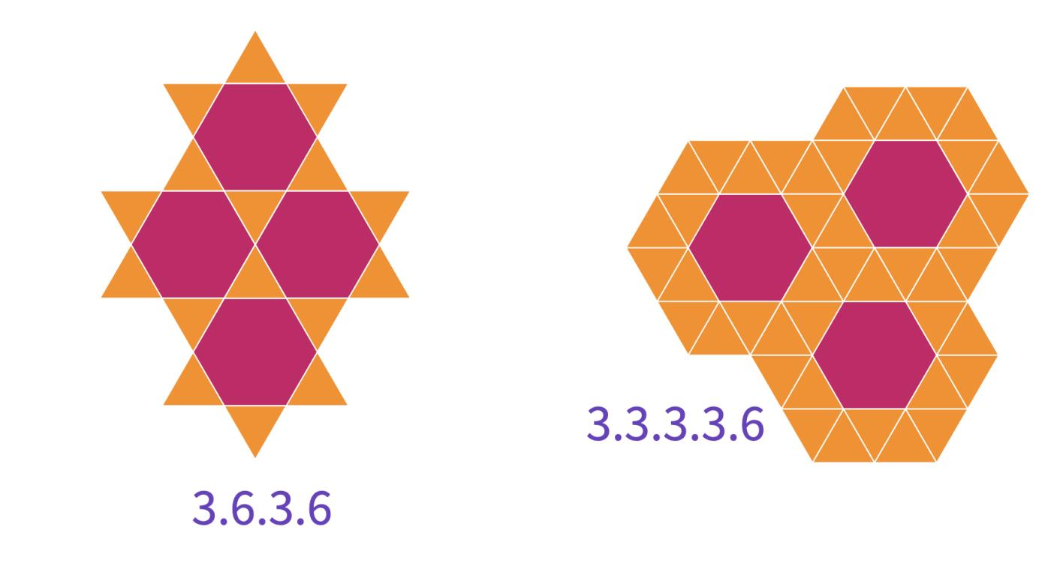

Definition
# Source: AI Source: Provided by: [Data Path: Persons Table -> ID Column: 1, Name_En Column: Motasem Essam] -> From: [ChatGPT] on [7/25/2026]
A Semi-Regular Tessellation is a tessellation of the Euclidean plane formed using two or more types of regular polygons, arranged so that the same sequence of regular polygons occurs around every vertex.
A semi-regular tessellation must satisfy:
- It uses two or more types of regular polygons.
- The polygons meet edge-to-edge.
- The same arrangement of polygons occurs at every vertex.
- There are no gaps or overlaps.
- The interior angles around every vertex sum to:
$$\boxed{{360}^{∘}}$$
Semi-regular tessellations are also commonly called Archimedean tessellations.

Fundamental Concept
# Source: AI Source: Provided by: [Data Path: Persons Table -> ID Column: 1, Name_En Column: Motasem Essam] -> From: [ChatGPT] on [7/25/2026]
Unlike a regular tessellation, which uses only one type of regular polygon, a semi-regular tessellation combines different regular polygons.
For example:
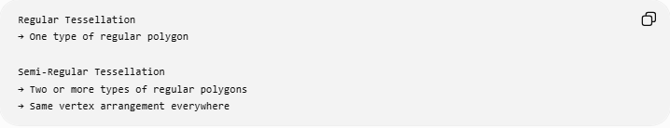
Regular Tessellation
→ One type of regular polygon

Semi-Regular Tessellation
→ Two or more types of regular polygons
→ Same vertex arrangement everywhere

Vertex Configuration
# Source: AI Source: Provided by: [Data Path: Persons Table -> ID Column: 1, Name_En Column: Motasem Essam] -> From: [ChatGPT] on [7/25/2026]
The arrangement of polygons around a vertex is described using a vertex configuration.
The number represents the number of sides of each polygon encountered around the vertex.
For example:
$$\boxed{3.6.3.6}$$
means:
Triangle → Hexagon → Triangle → Hexagon
around every vertex.
Another example:
$$\boxed{4.6.12}$$
means:
Square → Hexagon → Dodecagon
around every vertex.

Fundamental Angle Condition
# Source: AI Source: Provided by: [Data Path: Persons Table -> ID Column: 1, Name_En Column: Motasem Essam] -> From: [ChatGPT] on [7/25/2026]
The interior angles of all polygons meeting at a vertex must add to:
$$\boxed{{360}^{∘}}$$
For a regular $n$-gon, its interior angle is:
$$\boxed{θ_{n}=\frac{\left(n-2\right){180}^{∘}}{n}}$$
Therefore, for a vertex configuration such as $3.6.3.6$:
$${60}^{∘}+{120}^{∘}+{60}^{∘}+{120}^{∘}={360}^{∘}$$
so the arrangement can form a tessellation.

Classification of Semi-Regular Tessellations
# Source: AI Source: Provided by: [Data Path: Persons Table -> ID Column: 1, Name_En Column: Motasem Essam] -> From: [ChatGPT] on [7/25/2026]
There are 8 semi-regular tessellations of the Euclidean plane.
Semi-Regular Tessellations
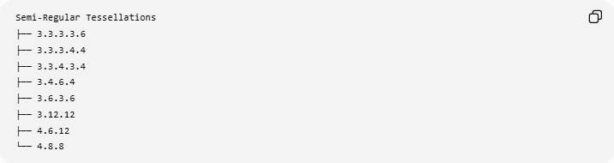
├── 3.3.3.3.6
├── 3.3.3.4.4
├── 3.3.4.3.4
├── 3.4.6.4
├── 3.6.3.6
├── 3.12.12
├── 4.6.12
└── 4.8.8
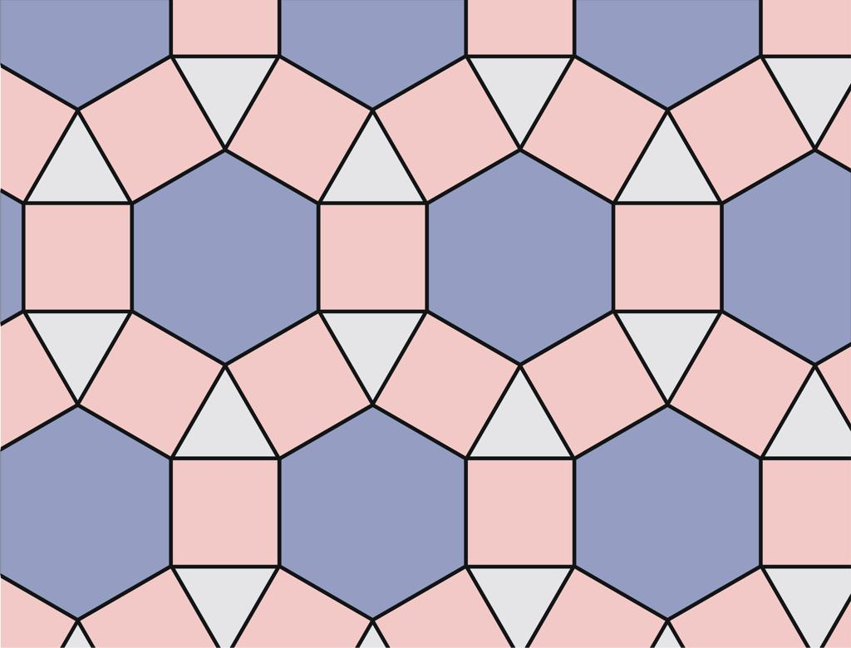
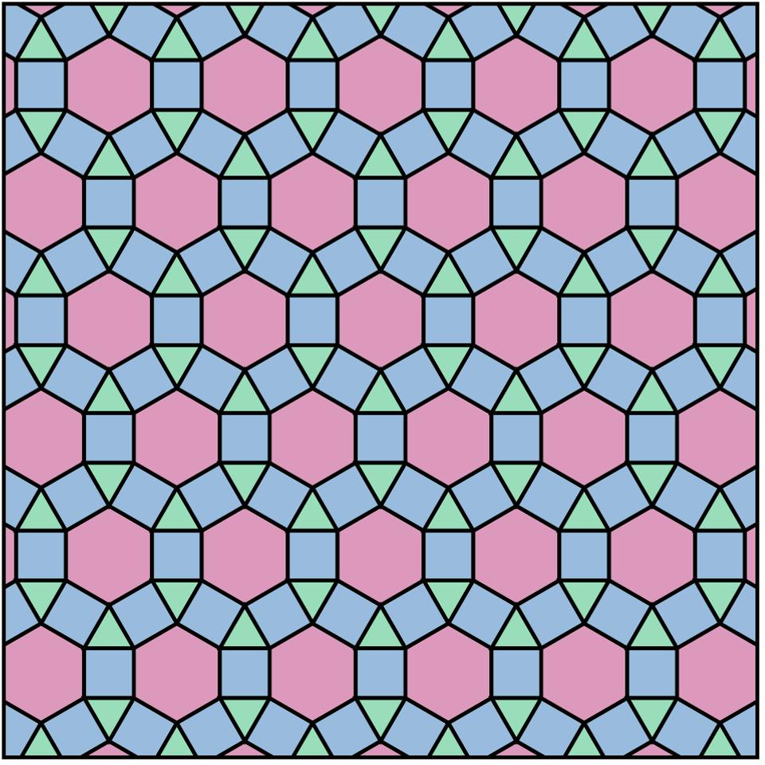
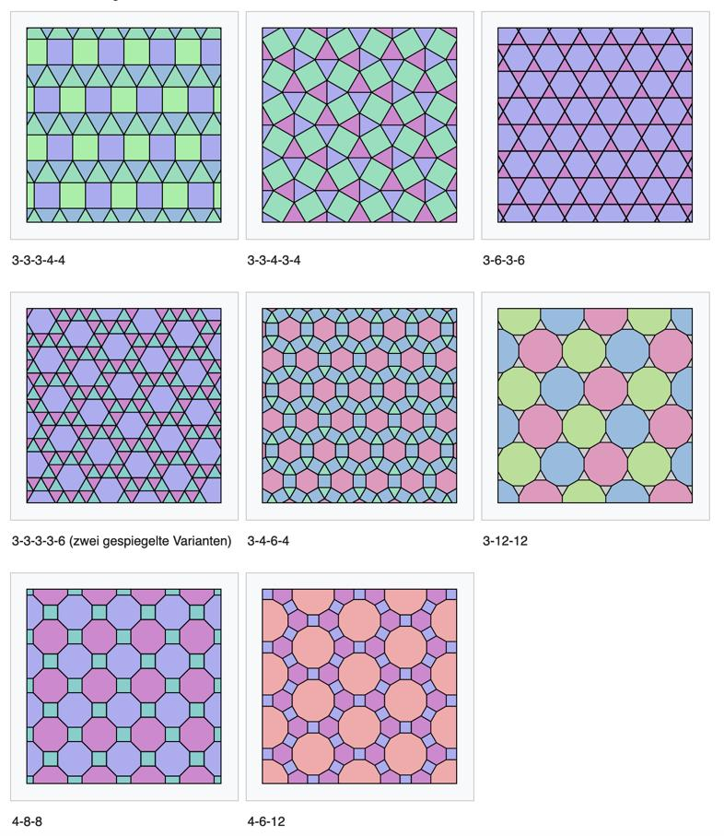
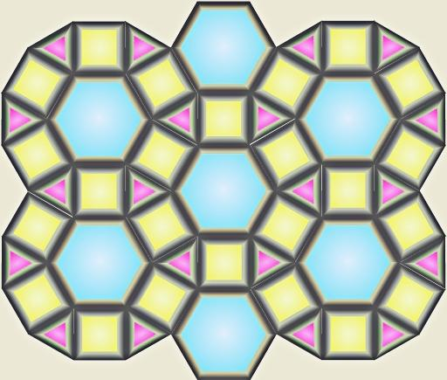
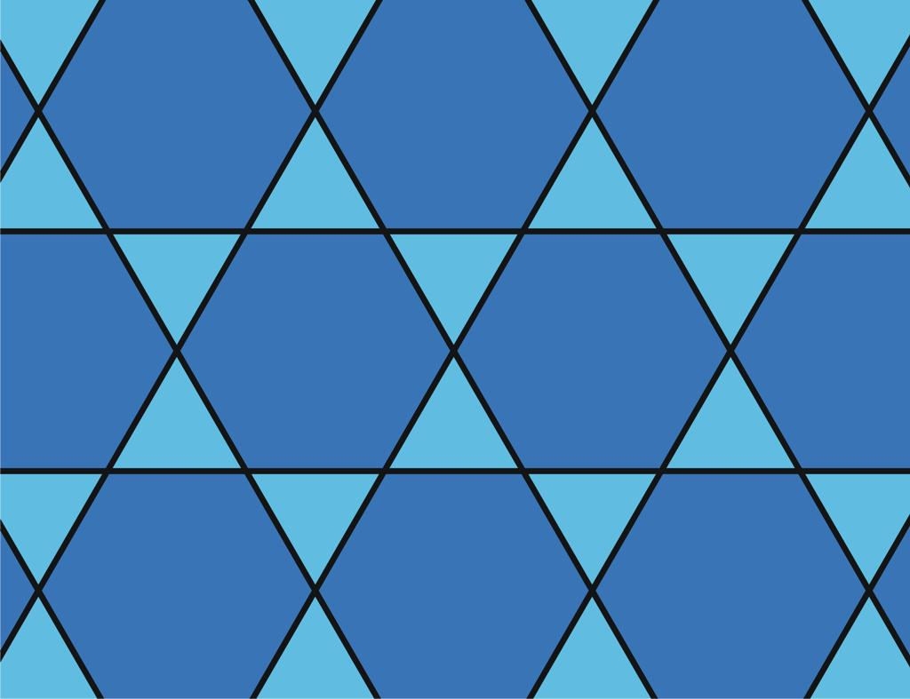
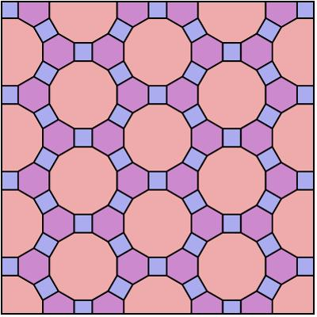
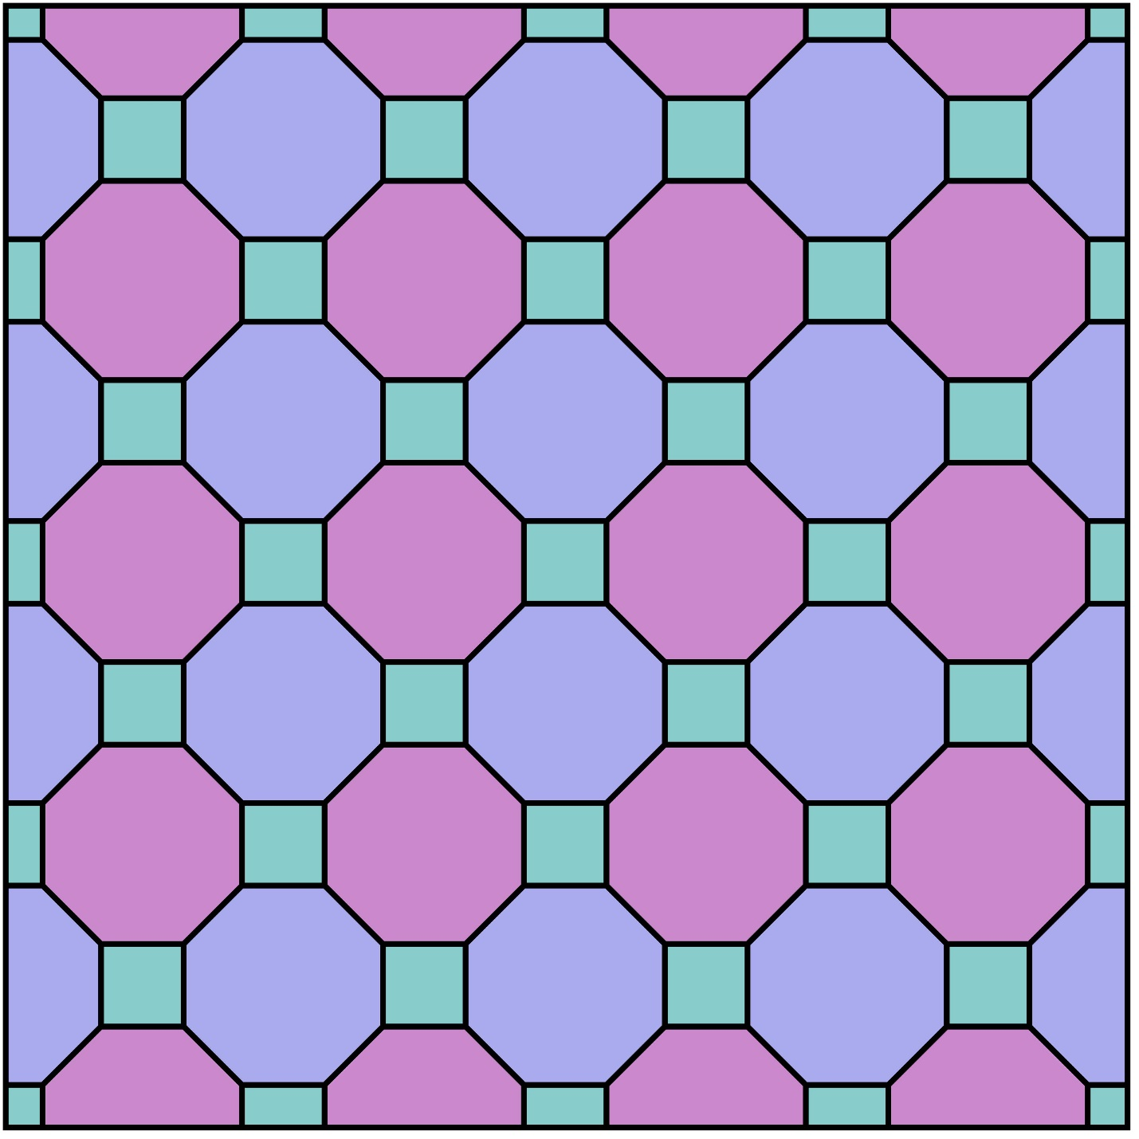
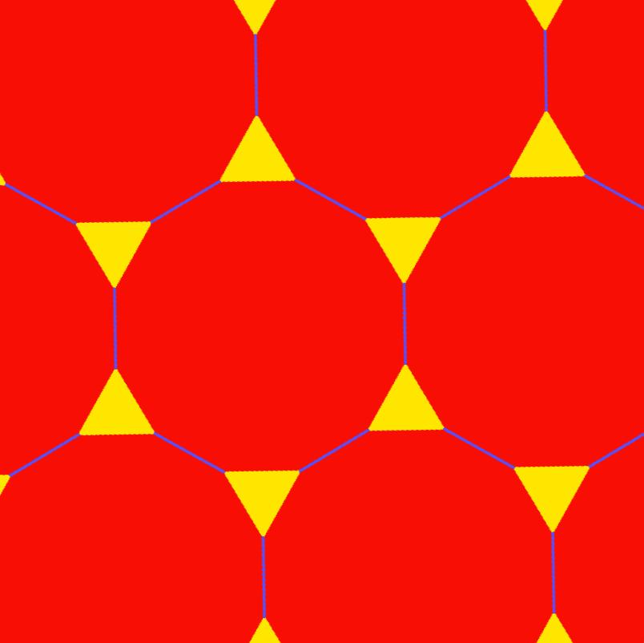

1. $3.3.3.3.6$
# Source: AI Source: Provided by: [Data Path: Persons Table -> ID Column: 1, Name_En Column: Motasem Essam] -> From: [ChatGPT] on [7/25/2026]
Uses:
- Four equilateral triangles
- One regular hexagon
Angles:
$${60}^{∘}+{60}^{∘}+{60}^{∘}+{60}^{∘}+{120}^{∘}={360}^{∘}$$

2. $3.3.3.4.4$
# Source: AI Source: Provided by: [Data Path: Persons Table -> ID Column: 1, Name_En Column: Motasem Essam] -> From: [ChatGPT] on [7/25/2026]
Uses:
- Three equilateral triangles
- Two squares
Angles:
$${60}^{∘}+{60}^{∘}+{60}^{∘}+{90}^{∘}+{90}^{∘}={360}^{∘}$$

3. $3.3.4.3.4$
# Source: AI Source: Provided by: [Data Path: Persons Table -> ID Column: 1, Name_En Column: Motasem Essam] -> From: [ChatGPT] on [7/25/2026]
Uses:
- Three equilateral triangles
- Two squares
However, the order around the vertex is different from $3.3.3.4.4$.
$${60}^{∘}+{60}^{∘}+{90}^{∘}+{60}^{∘}+{90}^{∘}={360}^{∘}$$
This demonstrates why the vertex configuration matters, not merely the types and quantities of polygons.

4. $3.4.6.4$
# Source: AI Source: Provided by: [Data Path: Persons Table -> ID Column: 1, Name_En Column: Motasem Essam] -> From: [ChatGPT] on [7/25/2026]
Uses:
- Two equilateral triangles
- Two squares
- One regular hexagon
$${60}^{∘}+{90}^{∘}+{120}^{∘}+{90}^{∘}={360}^{∘}$$
Notice that there are actually four polygons around the vertex:
$$\boxed{3.4.6.4}$$

5. $3.6.3.6$
# Source: AI Source: Provided by: [Data Path: Persons Table -> ID Column: 1, Name_En Column: Motasem Essam] -> From: [ChatGPT] on [7/25/2026]
Uses:
- Two equilateral triangles
- Two regular hexagons
$${60}^{∘}+{120}^{∘}+{60}^{∘}+{120}^{∘}={360}^{∘}$$
The triangle and hexagon alternate around each vertex.

6. $3.12.12$
# Source: AI Source: Provided by: [Data Path: Persons Table -> ID Column: 1, Name_En Column: Motasem Essam] -> From: [ChatGPT] on [7/25/2026]
Uses:
- One equilateral triangle
- Two regular dodecagons
$${60}^{∘}+{150}^{∘}+{150}^{∘}={360}^{∘}$$

7. $4.6.12$
# Source: AI Source: Provided by: [Data Path: Persons Table -> ID Column: 1, Name_En Column: Motasem Essam] -> From: [ChatGPT] on [7/25/2026]
Uses:
- One square
- One regular hexagon
- One regular dodecagon
$${90}^{∘}+{120}^{∘}+{150}^{∘}={360}^{∘}$$
This is particularly useful for demonstrating how three different regular polygons can fit together.

8. $4.8.8$
# Source: AI Source: Provided by: [Data Path: Persons Table -> ID Column: 1, Name_En Column: Motasem Essam] -> From: [ChatGPT] on [7/25/2026]
Uses:
- One square
- Two regular octagons
$${90}^{∘}+{135}^{∘}+{135}^{∘}={360}^{∘}$$

Summary Table
# Source: AI Source: Provided by: [Data Path: Persons Table -> ID Column: 1, Name_En Column: Motasem Essam] -> From: [ChatGPT] on [7/25/2026]
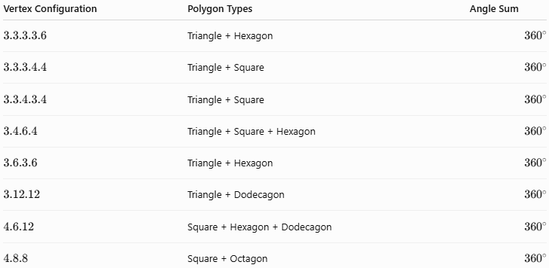
Vertex Configuration | Polygon Types | Angle Sum
$$3.3.3.3.6$$ | Triangle + Hexagon | $${360}^{∘}$$
$$3.3.3.4.4$$ | Triangle + Square | $${360}^{∘}$$
$$3.3.4.3.4$$ | Triangle + Square | $${360}^{∘}$$
$$3.4.6.4$$ | Triangle + Square + Hexagon | $${360}^{∘}$$
$$3.6.3.6$$ | Triangle + Hexagon | $${360}^{∘}$$
$$3.12.12$$ | Triangle + Dodecagon | $${360}^{∘}$$
$$4.6.12$$ | Square + Hexagon + Dodecagon | $${360}^{∘}$$
$$4.8.8$$ | Square + Octagon | $${360}^{∘}$$

Semi-Regular vs Regular Tessellation
# Source: AI Source: Provided by: [Data Path: Persons Table -> ID Column: 1, Name_En Column: Motasem Essam] -> From: [ChatGPT] on [7/25/2026]
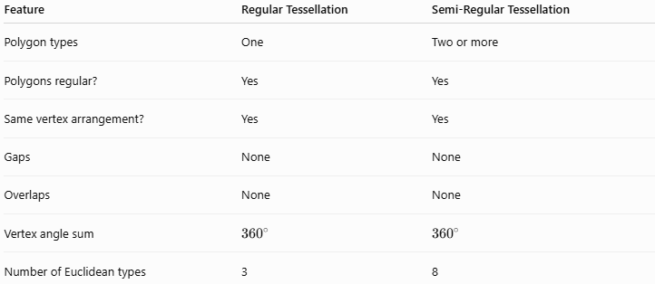
Feature | Regular Tessellation | Semi-Regular Tessellation
Polygon types | One | Two or more
Polygons regular? | Yes | Yes
Same vertex arrangement? | Yes | Yes
Gaps | None | None
Overlaps | None | None
Vertex angle sum | $${360}^{∘}$$ | $${360}^{∘}$$
Number of Euclidean types | 3 | 8

Semi-Regular vs Irregular Tessellation
# Source: AI Source: Provided by: [Data Path: Persons Table -> ID Column: 1, Name_En Column: Motasem Essam] -> From: [ChatGPT] on [7/25/2026]
A semi-regular tessellation uses regular polygons and has a uniform vertex arrangement.
An irregular tessellation may use polygons that are not regular and does not necessarily have the same vertex configuration everywhere.
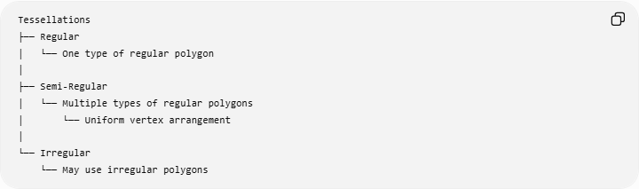
Tessellations
├── Regular
│ └── One type of regular polygon
│
├── Semi-Regular
│ └── Multiple types of regular polygons
│ └── Uniform vertex arrangement
│
└── Irregular
└── May use irregular polygons

Important Terminology
# Source: AI Source: Provided by: [Data Path: Persons Table -> ID Column: 1, Name_En Column: Motasem Essam] -> From: [ChatGPT] on [7/25/2026]
Uniform Vertex Arrangement
The same types of polygons occur around every vertex in the same cyclic order.
Vertex Configuration
A notation describing the polygons surrounding a vertex.
Example:
$$\boxed{4.6.12}$$
Archimedean Tessellation
Another common name for a semi-regular tessellation.
Edge-to-Edge
Adjacent polygons meet along complete edges rather than only along portions of edges.

Examples

Example 1
# Source: AI Source: Provided by: [Data Path: Persons Table -> ID Column: 1, Name_En Column: Motasem Essam] -> From: [ChatGPT] on [7/25/2026]
Consider:
$$3.6.3.6$$
The angles are:
$${60}^{∘}+{120}^{∘}+{60}^{∘}+{120}^{∘} \\ ={360}^{∘}$$
Therefore, the vertex satisfies the angle requirement for a semi-regular tessellation.

Example 2
# Source: AI Source: Provided by: [Data Path: Persons Table -> ID Column: 1, Name_En Column: Motasem Essam] -> From: [ChatGPT] on [7/25/2026]
Consider:
$$4.8.8 \\ {90}^{∘}+{135}^{∘}+{135}^{∘}={360}^{∘}$$
Therefore, squares and regular octagons can form this semi-regular tessellation.

Relationship with Regular Tessellations
# Source: AI Source: Provided by: [Data Path: Persons Table -> ID Column: 1, Name_En Column: Motasem Essam] -> From: [ChatGPT] on [7/25/2026]
Regular tessellations and semi-regular tessellations are closely related.
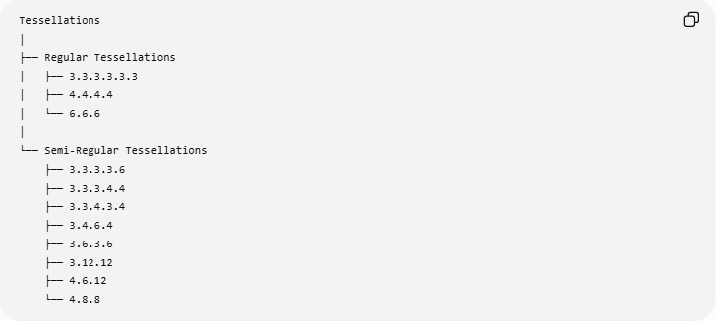
Tessellations
│
├── Regular Tessellations
│ ├── 3.3.3.3.3.3
│ ├── 4.4.4.4
│ └── 6.6.6
│
└── Semi-Regular Tessellations
├── 3.3.3.3.6
├── 3.3.3.4.4
├── 3.3.4.3.4
├── 3.4.6.4
├── 3.6.3.6
├── 3.12.12
├── 4.6.12
└── 4.8.8

Real-World Applications
# Source: AI Source: Provided by: [Data Path: Persons Table -> ID Column: 1, Name_En Column: Motasem Essam] -> From: [ChatGPT] on [7/25/2026]
Semi-regular tessellations are useful in:
- Architectural patterns
- Floor and wall designs
- Decorative geometry
- Islamic geometric design
- Computer graphics
- Mathematical visualization
- Pattern generation
- Structural design

Key Points
# Source: AI Source: Provided by: [Data Path: Persons Table -> ID Column: 1, Name_En Column: Motasem Essam] -> From: [ChatGPT] on [7/25/2026]
- A semi-regular tessellation uses two or more types of regular polygons.
- The polygons meet edge-to-edge.
- The same vertex configuration occurs throughout the tessellation.
- The angles around each vertex total:
$$\boxed{{360}^{∘}}$$
- There are 8 semi-regular tessellations in the Euclidean plane.
- Vertex configurations provide a compact way to describe them.
- Semi-regular tessellations are also commonly called Archimedean tessellations.

Conclusion
# Source: AI Source: Provided by: [Data Path: Persons Table -> ID Column: 1, Name_En Column: Motasem Essam] -> From: [ChatGPT] on [7/25/2026]
A Semi-Regular Tessellation extends the idea of a regular tessellation by combining multiple types of regular polygons while maintaining a uniform arrangement around every vertex. The eight Euclidean semi-regular tessellations are distinguished by their vertex configurations, such as $3.6.3.6$, $4.6.12$, and $4.8.8$.

